THEME PARK ASSIGNMENT
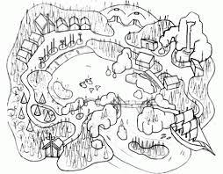
This assignment will showcase your creativity and understanding of Ethos, Logos, and Pathos. You have been asked to design a new theme park, and be original in your design and plans.
Procedure
You will work in a group. Your assignment is to design a theme park that is different from any other theme park currently in existence. Be as imaginative as possible. Assume that we have the technology necessary for your ideas. Money for construction is no object since you have already found a group of wealthy investors. As a group, you will present your theme part to the class.
Requirements
- Name of the Theme Park and theme:
- Cost of admissions (include special discounts for kids, senior citizens, group rates, etc.) and hours open:
- Information on shows and events:
- Information on park news:
- What makes it different from any other theme park?
- Where will your theme park be located?
- What are some of the attractions (rides, shows, shops, restaurants, hotels) you will have? Describe what each of these will look like and give them names.
- Draw a map of the park and its attractions (at least 8 rides and 4 attractions).
- Make an advertising brochure for your theme park. (The idea of the brochure is to showcase how exciting your rides are and everything to offer at your theme park. Include admission fees etc.)
- Write a brief one paragraph summary of the elements of persuasion used and how they were used. (Ethos, logos, pathos)

Draft due date: __________________
Final due date: __________________

Names of those in your group:_____________________________________________________
Grade Scale
Aspects | Poor 0 | Needs Improvement 6 | Good 8 | Outstanding 10
Overall theme park design | Little attention was given to the design of the theme park. There was no discernable theme to the ride. | Little planning went into the design of the theme park. | Student complied with all aspects of the design brief. A simple but effective theme was present throughout the theme park. | Care was taken to incorporate the elements of the design brief and seamlessly match them with the overall theme of the park
Ride selection and amusements | Fewer than 4 rides/ amusements were included. | Less than 8 rides or amusements were included. | Less than 10 rides and amusements were included. | 12 amusements and rides were included.
Map | No map was included. | A simple map was included but key elements were missing. | A simple map was created which highlighted the features of the theme park. | A completed map was provided with all major components of the theme park.
Brochure | No brochure was included | A simple brochure without key elements | A simple brochure that showcases the theme park | A complete brochure with all required elements.
One paragraph summary | Elements of persuasion were used poorly. | Favors the use of one element of persuasion. | Flawed uses of the three elements of persuasion, but they are equally blended. | Uses all 3 forms of persuasion perfectly.

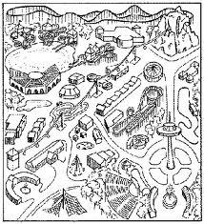
Final Grade__________________/ 50

